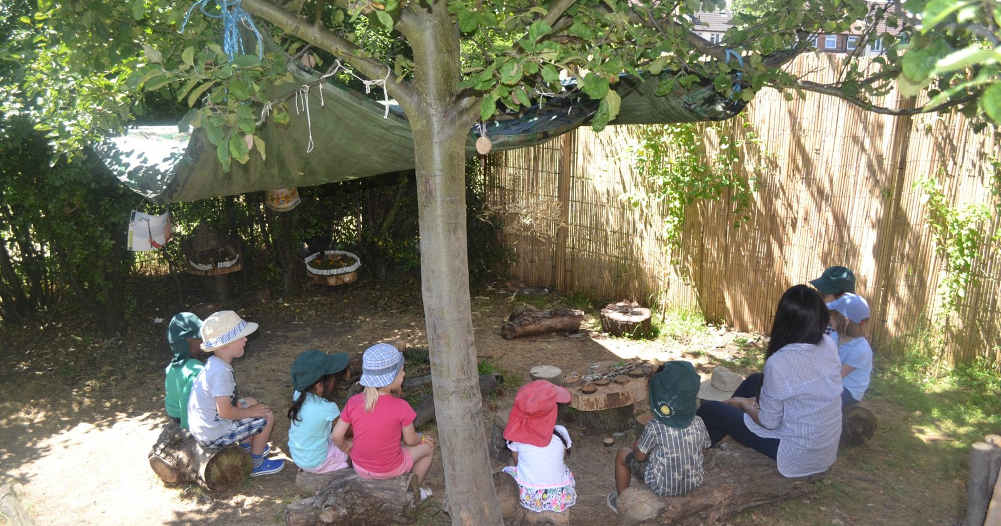
CANDIDATE INFORMATION PACK
Assistant Headteacher
Pembury House Nursery School & Children’s Centre
Haringey Early Years Schools Alliance (HEYSA)
Leadership Scale L1–6 • Closing date: Monday 19 October 2026, 12 noon

 |  | 

Welcome from the Executive Headteacher

Thank you for your interest in the Assistant Headteacher role at Haringey Early Years Schools Alliance and Children’s Centres, based at Pembury House. The Governing Body and I are looking to appoint a dynamic, visionary leader for our unique learning community.
Rowland Hill, Woodlands Park and Pembury House Nursery Schools each consist of a Nursery School and Children’s Centre, with a wonderful array of well-resourced learning environments both inside and outside. We strive to provide interesting and inspiring environments for our children, families, visitors and staff.  We are proud of our federation and the collaborative work we are currently engaged in, both within the federation and across the borough. We are also a member school of HEP (Haringey Education Partnership); we believe that schools can achieve more by working collaboratively. | At a glance  ROLE  Assistant Headteacher  SCHOOL  Pembury House Nursery School & Children’s Centre  PAY  Leadership Scale L1–6  PATTERN  Full Time Class-based, 0.8 days a week  CLOSING  Mon 19 Oct 2026, 12 noon

At HEYSA we pride ourselves on our inclusive approach to education. We work tirelessly to provide our children and their families with the support they need to achieve the best possible outcomes. Governors and staff alike are committed to building upon the strong foundations embedded throughout and are extremely enthusiastic and focused on maintaining our high expectations.
The vision and values drive all we do at HEYSA, where dedicated staff and strong leaders ensure all children get the best start in life. You will work with the Head of School to ensure the best start in life for children in our school and children’s centre.
We are really looking forward to the next step on our journey and hope you will consider joining us. Visits to the school are warmly welcomed, when we can have an informal discussion about the post and give you a tour of the schools. Our school website and social media channels are a wealth of information. We encourage you to apply and look forward to meeting you.

Sian McDermott  Executive Headteacher | Zurine Anllo  Head of School

Job Description
Assistant Headteacher • Leadership Scale L1–6
Purpose of the job
Share in the leadership of the school by working in partnership with the Head of School and the leadership team across the federation to provide an exceptional education for the children. Ensure sustained school improvement in the quality of teaching and learning throughout the school, and in the aspects of school life for which you are accountable.
This is a class-based position, 0.8 days a week.
Key accountabilities
✓ Shared leadership of the school as a member of the leadership team | ✓ Deputise for the Head of School
✓ Quality of teaching, learning (including environments), assessment and achievement across the school | ✓ Strategic leadership of a curriculum area of learning
✓ Day-to-day leadership, organisation and management of staff and children within a teaching and learning team | ✓ Manage staff performance and supervision, and improve the professional skills of colleagues
✓ Teach to an exemplary standard | ✓ Budget management
01 Share, articulate and contribute to the vision of the Federation and Governing Body for the aspirations and improvement of the school
- Ensure staff are regularly reminded of the aims and aspirations of the school and federation
- Keep the aspirations of the school to the fore when working with staff
- Be vocal in promoting this vision to staff, children and parents
- Promote this vision during your contributions to meetings
- Attend school and federation leadership team meetings as required
02 Lead the staff to ensure the quality of teaching and learning
- Lead staff training to ensure teaching and learning is effective, so children make good progress
- Monitor teaching and learning outcomes and be responsive in developing the learning environments
- Use data and benchmarking to monitor progress in every child’s learning, and use this to ensure quality intervention prevents underachievement
- Ensure a culture and ethos of challenge and support where all children (especially the most vulnerable) can achieve success and become engaged in their own learning, removing barriers
- Determine, organise and implement a diverse, flexible curriculum and an effective assessment framework
- Plan and deliver training for our consortium
03 Leadership and management of the school’s day-to-day assessment procedures
- Lead the school’s formative and summative assessment cycle and ensure it is relevant and delivered to deadline
- Lead pupil progress meetings, in partnership with the Head of School, to ensure underachievement is identified and addressed, focusing on the most vulnerable learners
- Support staff in using assessment information to understand what children can do and the next steps they need to make in their learning
04 Take responsibility for the leadership of a curriculum subject and curriculum team
- Lead the school’s curriculum, teaching and learning
- Be accountable for children’s progress and standards of achievement
- Monitor and evaluate the quality of the curriculum and the quality of teaching and learning
- Keep abreast of current educational thinking and work proactively to ensure the key stage positively adopts fresh ideas to enhance the quality of teaching
05 Day-to-day leadership, organisation and management of staff and children
- Ensure that key issues for school improvement (and agreed federation policies) are discussed, actioned and receive a high profile across the teams
- Ensure curriculum coverage through our child-initiated approaches to teaching
- Monitor and evaluate the range and quality of the school experience provided for the children
- Ensure that day-to-day matters are well organised, with events communicated to colleagues (and families)
- Ensure the learning environment promotes effective learning and a positive experience of school
- Ensure the behaviour and attendance of the children is well managed
- Ensure agreed innovation and change are securely embedded across the team, and the reasons for the change or action are clearly understood by staff
- Ensure the transition of children to the next phase of their education is effective
- Ensure the team offers a good range of opportunities for parents to engage in school life and understand how we teach the children and would like them to learn
06 Manage the performance of staff within the team
- Lead performance management reviews and staff supervision
- Improve staff performance and manage the differing experiences and aspirations of staff by mentoring, coaching and challenging performance
- Motivate and inspire
- Work with teams and individuals to offer individual and collective support to staff working under the challenges of teaching today

07 Improve the teaching and professional skills of colleagues in a manner that has a positive impact on pupil achievement and progress
- Line manages staff and leads a curriculum teams
- Work alongside colleagues in the classroom as an exceptional role model
- Ensure equality of opportunity in all activities of the team
08 Be an exemplar of good practice
- In your own classroom teaching and organisation and early years pedagogy.
- In your willingness to take on board new initiatives for school improvement through action research and work in our training consortium.
09 Manage the relevant curriculum budgets
- Plan action to impact effectively on school improvement

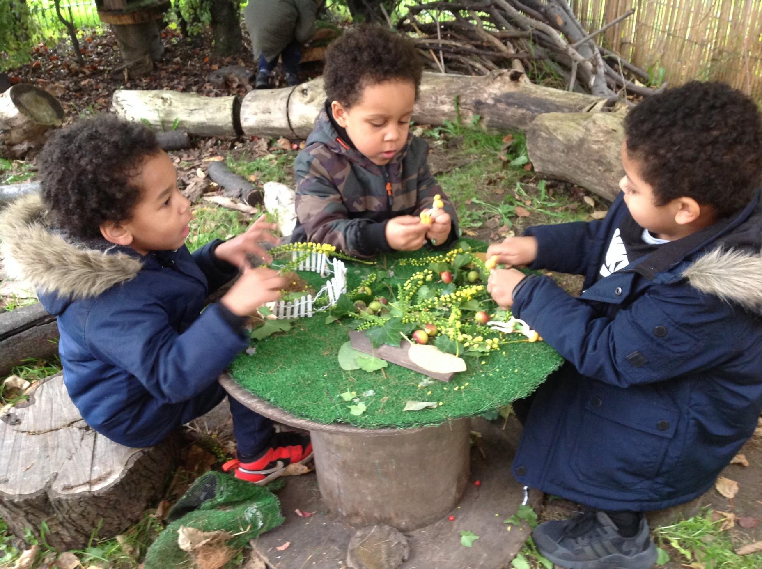 | 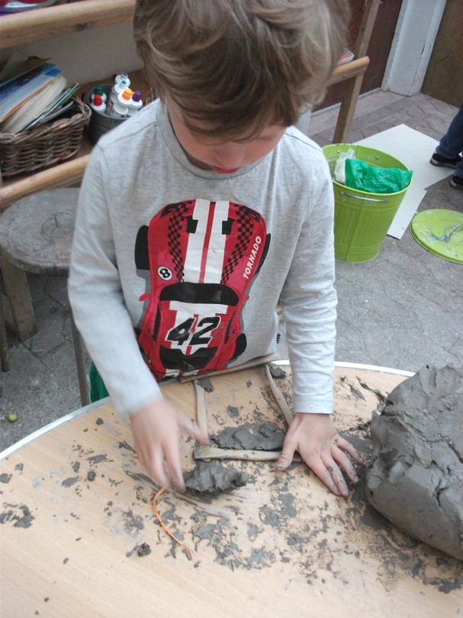

Person Specification
Important information for candidates thinking of applying for this post
Please make sure your application provides evidence against the criteria below.
Key: Essential / Desirable • Evidenced by: A = Application I = Interview T = Task

Criteria | Essential / Desirable | Evidenced by
Qualifications
Qualified Teacher Status | Essential | A
Degree | Essential | A
Relevant leadership qualifications, knowledge and experience (NPQ) | Desirable | A
Knowledge and understanding of the Early Years Foundation Stage curriculum, and able to demonstrate strategic leadership | Essential | A
Experience of teaching in more than one school and across the age range | Essential | A, I
Knowledge of exemplary practice in building good working relationships with families and partners in the school and children’s centre community | Essential | A, I, T
Knowledge and understanding
Familiarity with current national developments in Early Years practice and SEND legislation | Essential | A, I, T
Recent professional development in educational leadership | Desirable | A, I
Knowledge of a Children’s Centre’s core purpose | Desirable | A, I
A deep-rooted understanding of child development, pedagogy and factors affecting development and well-being | Essential | A, I, T
A comprehensive understanding of the Ofsted Education Inspection Framework | Essential | A, I
Understanding of how to work alongside the headteacher to develop and communicate a shared vision | Essential | A, I
Experience
An outstanding practitioner, with experience of delivering a child-centred, active learning curriculum | Essential | A, I
A proven track record of raising achievement for a range of pupil groups, including children with SEND and vulnerable groups | Essential | A, I
Experience of leading and developing a team through motivation towards a shared goal | Essential | A, I
Experience of supporting, monitoring, coaching and performance managing staff | Essential | A, I, T
Experience of EYFS curriculum design (‘Intent, Implementation and Impact’) | Desirable | A, I
Direct experience of strategic budget management | Desirable | A, I, T
Skills and abilities
Able to demonstrate and articulate outstanding teaching practice; able to lead and participate in professional development | Essential | A, I, T
Able to lead teams and to manage and resolve conflicts | Essential | I
An organised and methodical leader who can manage themselves and others with competing demands | Essential | A
Has successfully led the development of an aspect of teaching and learning and evaluated its impact | Essential | A, I
Flexibility, commitment and a desire to be involved in new initiatives | Essential | A, I
The ability to extract salient points from complex data, such as pupil progress or financial reports | Essential | T
A skilled and versatile communicator who is able to adjust tone and content to suit context | Essential | I, T
A leader who walks the talk with resilience, reflection and energy, with a commitment to working in networks beyond the school | Essential | A, I, T
Safeguarding
Demonstrates understanding of and commitment to safeguarding children | Essential | A, I
Able to track pupil attendance to ensure all children are in school and learning | Desirable | A, I
Knows how to sustain a safe environment and employ practices that promote everyone’s health and safety | Essential | A, I
Up-to-date professional development regarding current safeguarding legislation | Essential | A, I
Has undertaken DSL and Safer Recruitment training | Desirable | A
Strategic development
Experience of school improvement planning | Essential | A, I
A commitment to the ongoing development of school-to-school support and partnership opportunities beyond the school | Essential | I
An understanding of the benefits of the Haringey Nursery Schools Training Consortium (HNSTC) and collaborative work with Haringey nursery schools delivering training | Desirable | A, I

How to Apply

Pembury House is a dynamic and exciting place to work. To fully understand the school and centre, visits are expected – a chance to learn about the school and the HEYSA Federation.

Book a visit  Email  admin@pemburyhouse.haringey.sch.uk  Phone  020 8801 9914 | Find out more  Pembury House  www.pemburyhouse.haringey.sch.uk  Rowland Hill / Woodlands Park / Training Consortium  www.rowlandhill.haringey.sch.uk
Key dates
Closing date | Monday 19 October 2026, 12 noon
Shortlisting | Monday 19 October 2026, 1 pm
Interviews | Thursday 22nd October

Please do not submit a CV in place of the application form. Shortlisted candidates will be subject to online checks. Completed applications should be returned to admin@pemburyhouse.haringey.sch.uk.



We look forward to hearing from you
Haringey Early Years Schools Alliance

